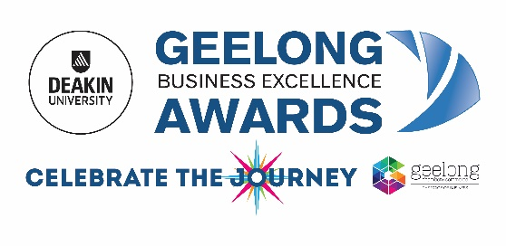
OFFICIAL APPLICATION FORM – BUSINESS ENTRY - 2019
Name of Entrant (Company/Department/Individual): |  | In the event that you win an award, please state the name
____________________________________________ |  | and title of the person (one only) who will accept the award
Postal Address: |  | at the Award Presentation Function
____________________________________________ |  | Name:
____________________________________________ |  | ______________________________________________________
Location of Judges Visit: |  | Title:
____________________________________________ |  | ______________________________________________________
____________________________________________` |  | What is the ownership of the business?
Name of Contact Person: |  | (Owner operated, corporate, other - please specify)
____________________________________________ |  | ______________________________________________________
Telephone: __________________________________ |  | How many employees (Full Time Equivalent) do you have?
 |  | ______________________________________________________
Email: ______________________________________ |  | Number of words in entry (not including a cover page) ________
I have no objection to my business being considered for media coverage including the use of my Business Summary from my official entry Yes
Please tick the box to confirm that your business/organisation satisfies all regulations and licensing requirements, and that all
statutory liabilities - Workcover, income tax, GST, Payroll Tax (if applicable) have been paid.
SELECTED CATEGORIES (Please tick/highlight)
 | Business of the Year (all entries are automatically eligible for Business of the Year)
 | Advanced Manufacturing & Industry
 | Best First Year Entry
 | Clever & Creative Sustainable Business
 | Corporate Social Responsibility
 | Customer Service
 | Digital Engagement
 | Emerging Business - under 3 years
 | Health & Wellbeing
 | Health Promoting Workplace
 | Home based and Micro Business – 1-3 employees/FTE (full time or equivalent)
 | Inclusive & Accessible Business
 | Innovation, Research & Development
 | Medium to Large Business or Division of a business – 21+ employees/FTE (full time or equivalent)
 | Regional Business
 | Retail Business
 | Small Business or Division of a business - 4 to 20 employees/FTE (full time or equivalent)
 | Tourism & Hospitality
Please note: This form is an overview only and is not to be seen as a substitute for the criteria to be answered in the body of the submission. Submit your entry as a WORD doc on www.gbea.com.au and post or deliver four (4) printed copies of your submission with a copy of application form attached to each to: Deakin University Geelong Business Excellence Awards, Level 2/10 Moorabool St, Geelong 3220
I ______________________________as _______________________________and an authorised person for this business declare that
- the financial and business performance information included in this entry has been presented so as to give a fair and true record of the trading of the business and
- at the date of this declaration, there are reasonable ground to believe that the business is solvent and can pay its debts as and
when they fall due
Signed: __________________________________ Dated: _______________________________

